

Cloud Computing

Cloud Based Code Manager

Project Report

Branch: - ICT

Group No: - 2

Mentor: - Dr. Sanjay Chaudhary

Team Members:

|  |  |
| --- | --- |
| Shreyas Patel | 1401025 |
| Ashutosh Kakadiya | 1401075 |
| Mihir Gajjar | 1401076 |
| Harsh Mehta | 1401086 |

# Acknowledgement

We would like to thank our academic mentor Dr. Sanjay Chaudhary for their persistent support and pivotal guidance throughout the course of the project and for providing us an opportunity to overcome theoretical knowledge by using and applying it to create realistic application.

Contents

Acknowledgement 2

Abstract 4

Project Description 4

Physical and Logical Design 5

Cloud Architecture 5

Application Architecture 5

Logical Design 6

Dataflow Diagram 7

Database Schema 8

Services 9

Authentication 9

Sign-up 9

Email 9

Forgot password 9

File manager 9

Compilation 9

Code Optimization 10

Savefile 10

Server allocation 10

Features 11

Result 11

Conclusion 21

Future Work 21

References 21

Annexure 22

# Abstract

Build cloud based web application that provides developer an interface which helps in code compilation, execution, storage, analysis and also provides code optimisation related suggestion if required in code.

# Project Description

* Generally, for writing and practicing of code, programmer has to install different IDEs for different coding languages or has to set up coding environment on their PCs. Instead of that we are providing cloud based service oriented platform where, one can find different coding languages available online on cloud. One only needs a browser to access all services like authentication, registration, compilation, execution, analysis of code and get suggestions for code optimizations. User can also save their code for future reference and access.
* In code analysis, we provide the Memory and Time Usage of the code. In code optimization, we suggest the user that which lines in the code can be removed to improve the code performance.
* In future, we are planning to provide service which enables solution of error generated during code compilation.

# Physical and Logical Design

## Cloud Architecture

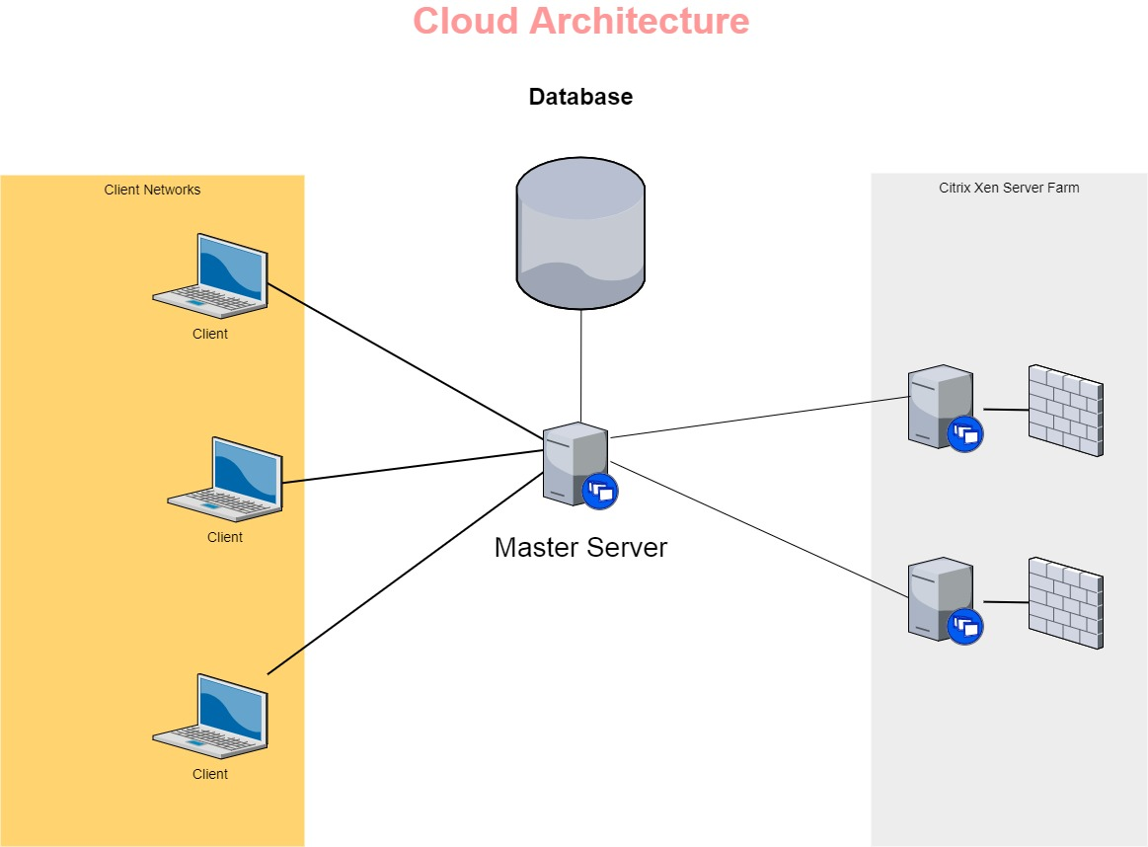

## Application Architecture

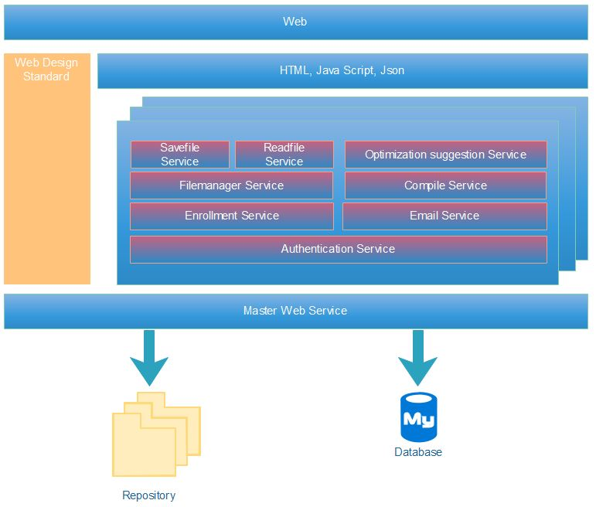

## Logical Design

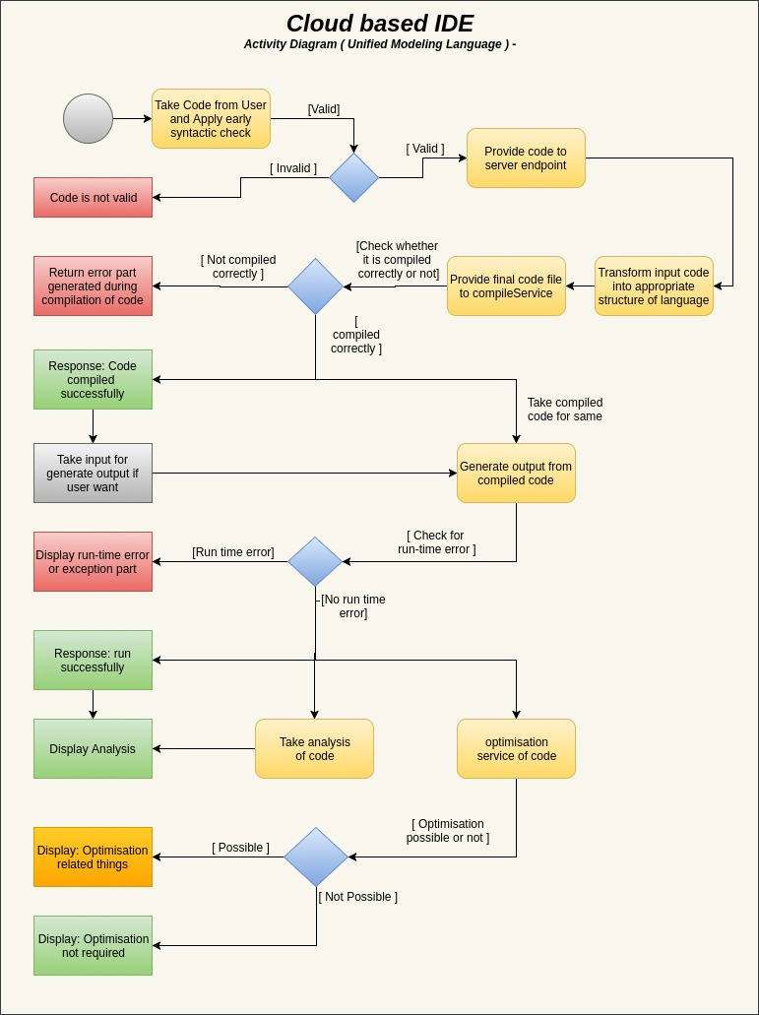

## Dataflow Diagram

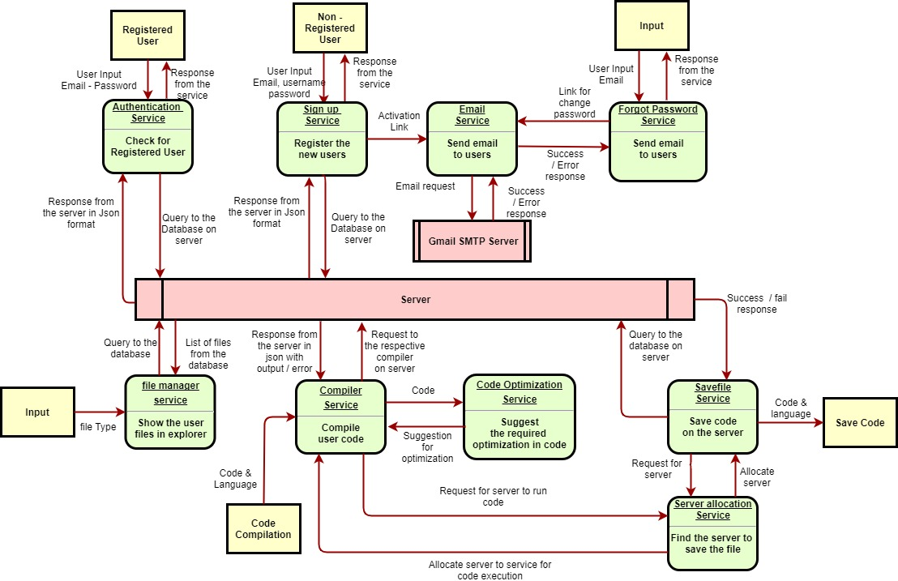

## Database Schema

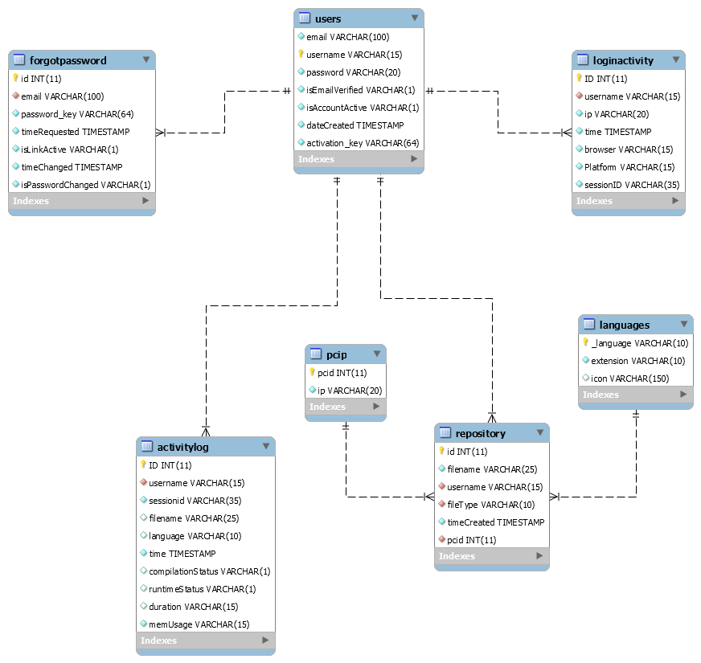

# Services

### Authentication

This service compares the credentials provided by the user with the database of authorized users’ information. If the credentials match, the process is completed and the user is granted authorization for access. If the credentials do not match, the user is not granted access and is requested to enter valid credentials to gain access.

### Sign-up

If the user is not registered, then the user can use this service and enter his details (sign - up) which will be added to the database of authorized users. This service provides the email service with the activation link that the user can use to complete the registration process.

### Email

This service, using the **Gmail SMTP Server**, sends emails to the users containing the link for completing the registration process or for changing the password in case the user forgot the password.

### Forgot password

In case the user has forgotten the password, this service can be used to change the password. It provides the email service with the link that the user can use to change the password.

### File manager

This service shows the user all the files that the user has saved. In addition, it also provides the user, specific types of files which the user wishes to see.

### Compilation

This service performs the primary function i.e. it performs the compilation of the codes for the users. It requests the server allocation service to allocate a machine for the compilation of the code. The user provides the service as an input: the code and the language in which it has to be compiled. If the compilation of the code was successful, then this service calls the code optimization service which takes the code as an input and provides suggestions for optimization. In this case, the output of the code and the suggestions for optimization of the code are both returned to the user. If the compilation of the code was not successful, it returns the error which occurred during the compilation process.

At this stage, the compiler service compiles the code for C, C++, Java and Python.

### Code Optimization

This service takes the file containing the code as an input, analyses the code and provides suggestions, which if implemented can optimize the performance in terms of the memory usage or the run-time of the code.

At this stage, this service optimize the code for Java and Python.

### Savefile

This service is used to save the code entered by the user in the database so that it can be accessed in the future. It requests the server allocation service to allocate a machine in which the code can be stored.

### Server allocation

This service performs the function of allocating the machines and distributing the jobs for compilation and data storage. It checks the status for memory usage and storage availability in various machines that are available on the server side and allocates the machine which will be most suitable for compilation of the code or for storing the file containing the code.

# Features

* Multitenancy Developed
* Customizable GUI Working
* Customizable business logic Working
* Subscription Developed
* Monitoring and billing Developed [Monitoring]
* Security and privacy Developed [privacy], Working on Security
* Scalability, high availability and reliability Developed
* Managing and administration for separate tenant Developed
* Runtime per tenant customization Working

# Result

* Home Screen  
    
  
* Login Screen  
    
    
  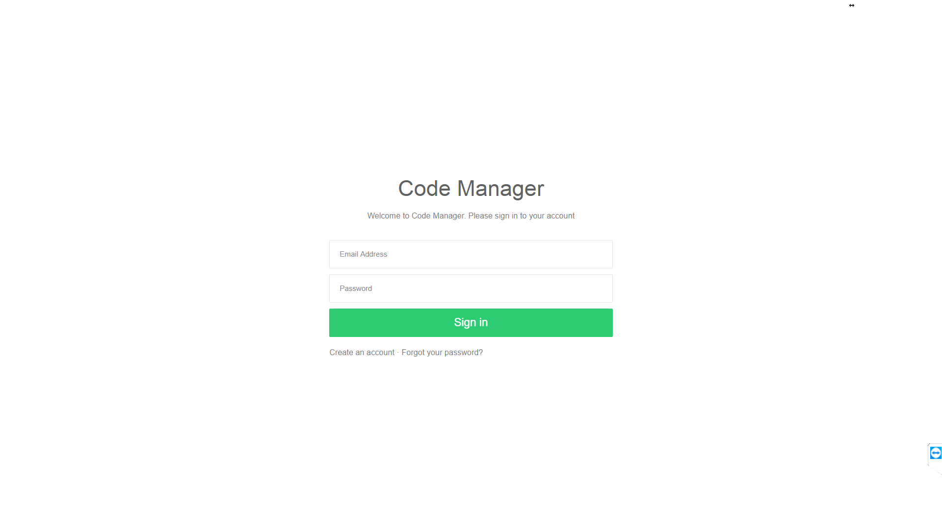

* Error based on user side input validation   
    
  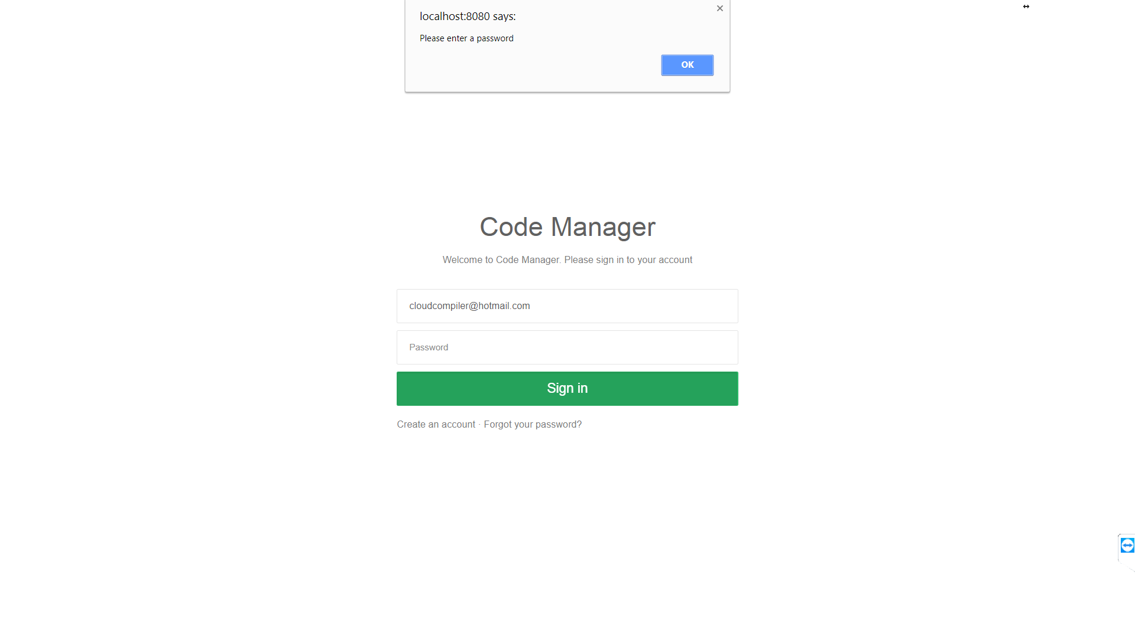
* Error based on server side validation  
    
  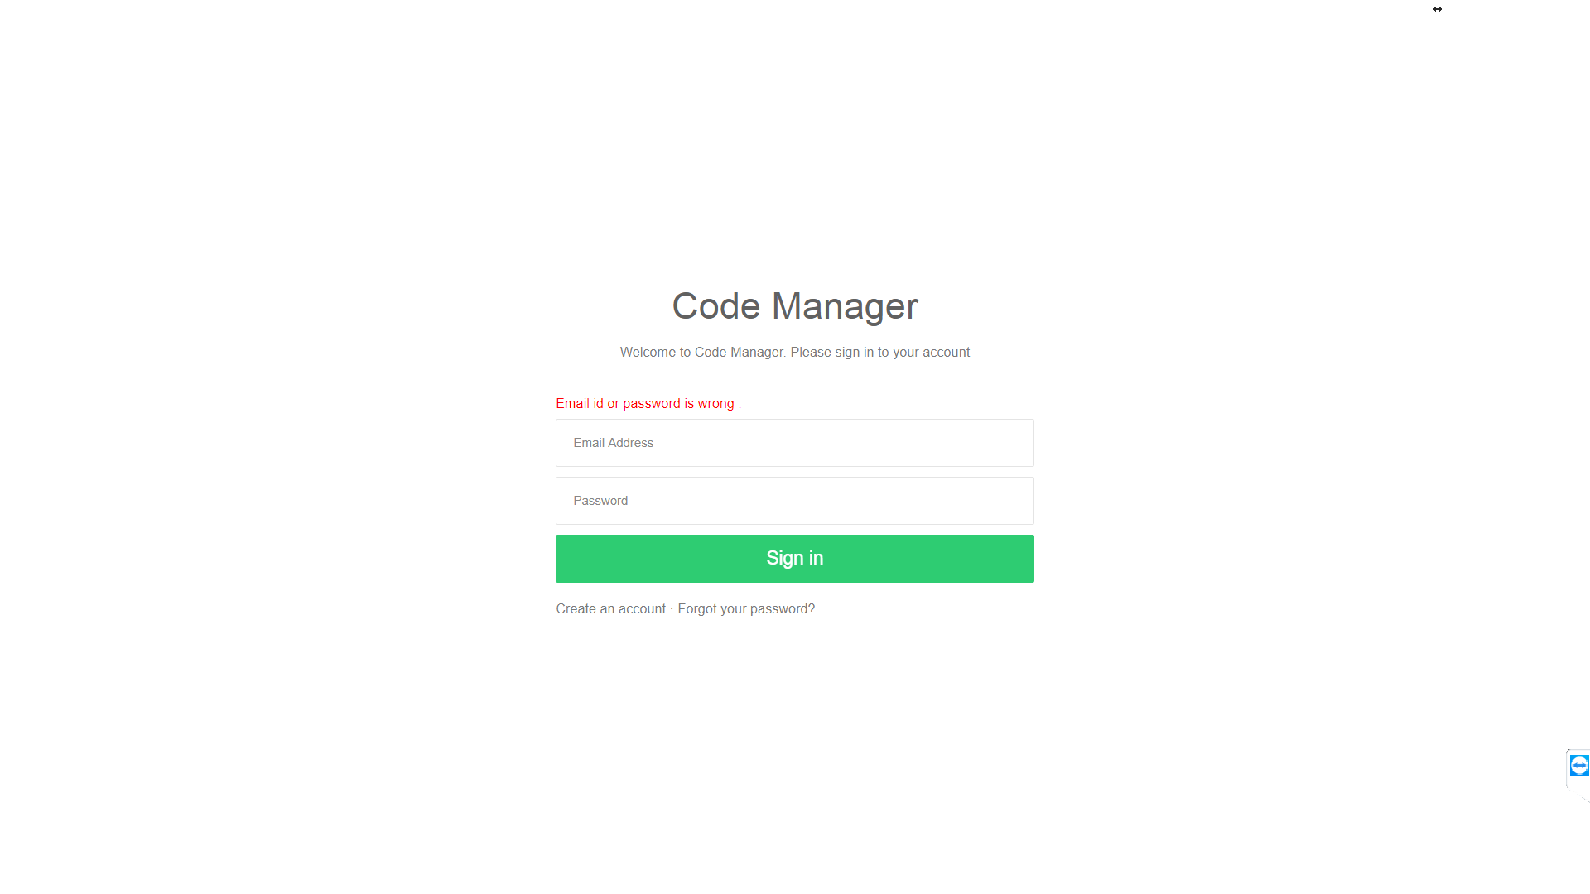
* User need to verify the account before login by clicking the link sent to user’s mail account  
    
  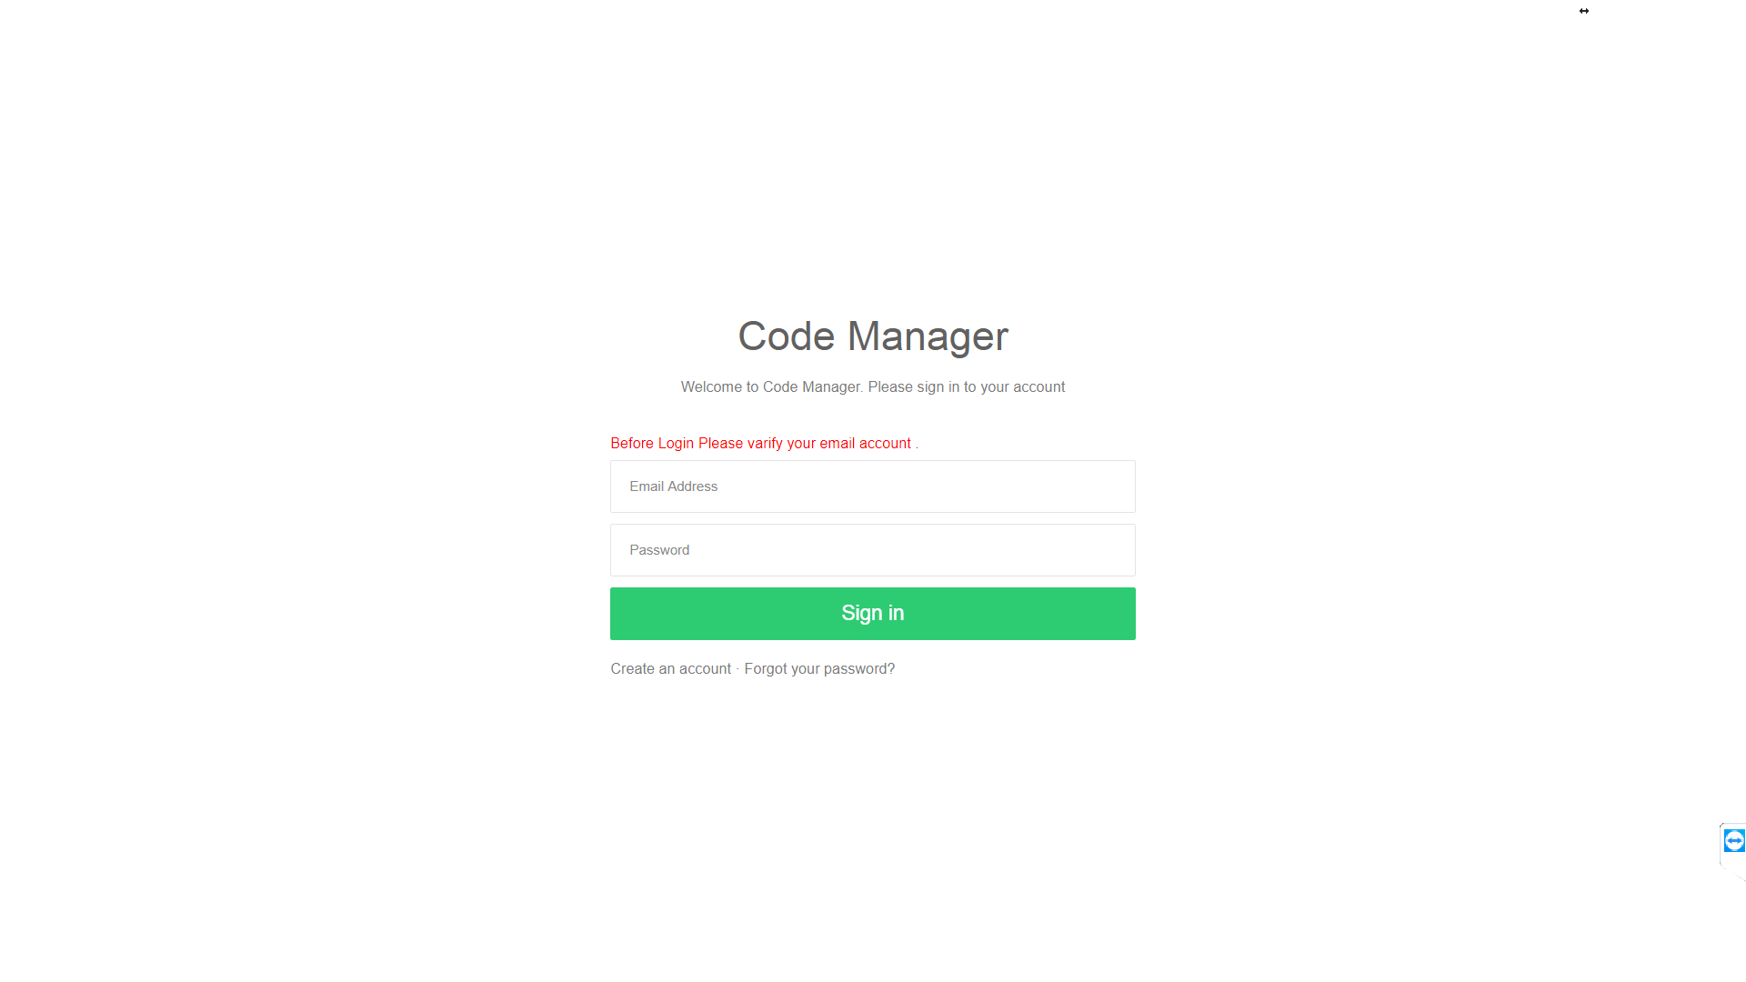
* Sign up screen  
    
  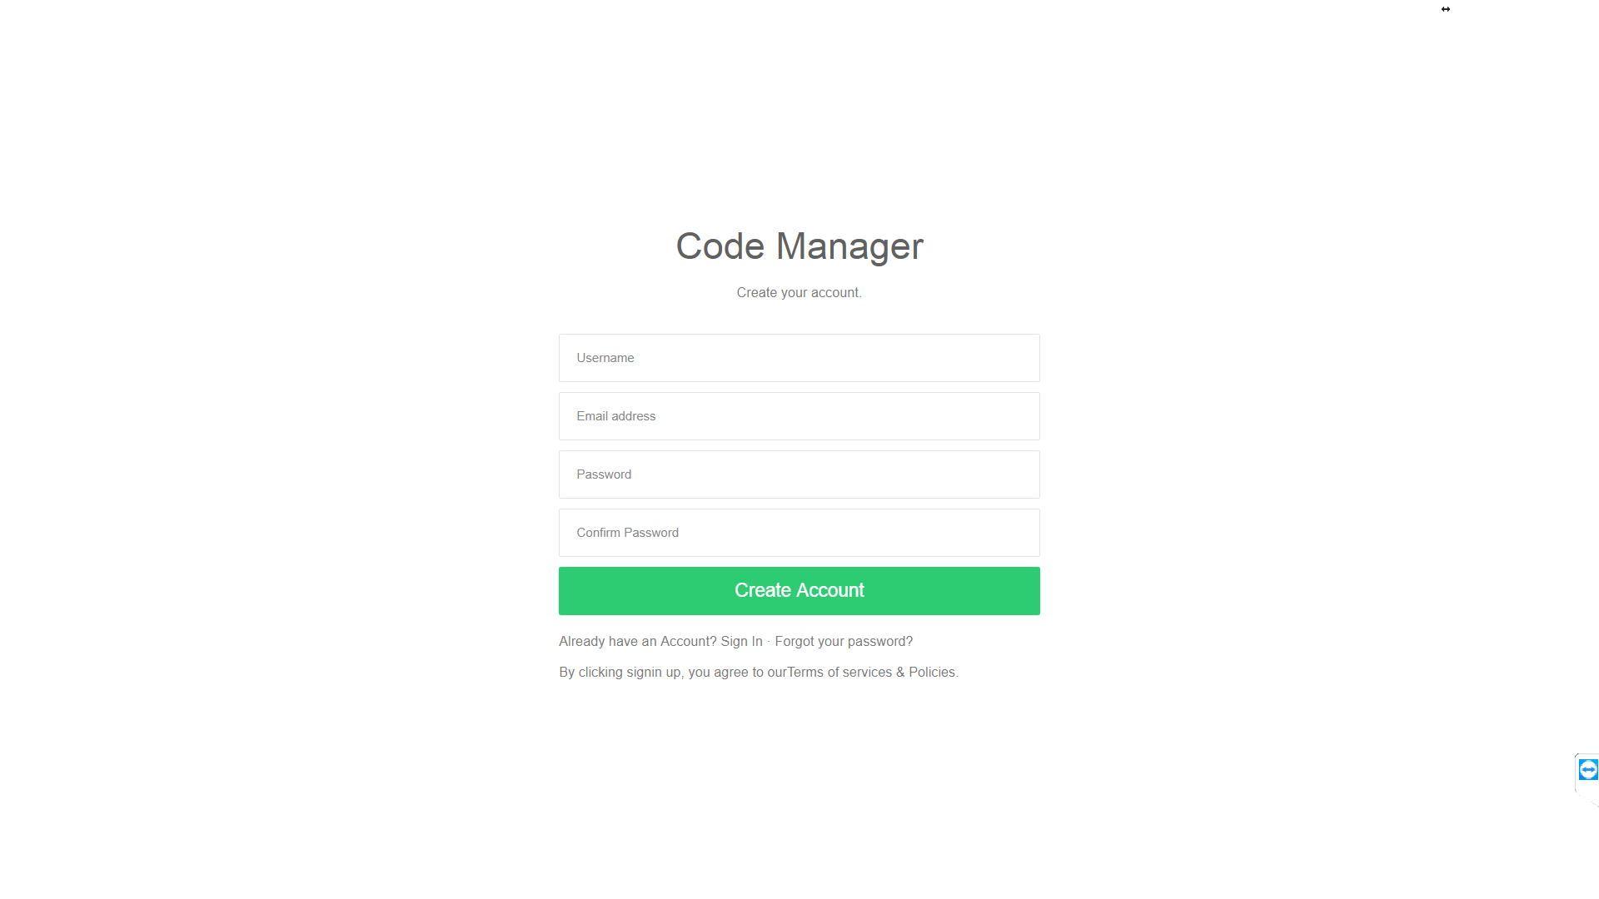
* Server side validation for sign up  
    
  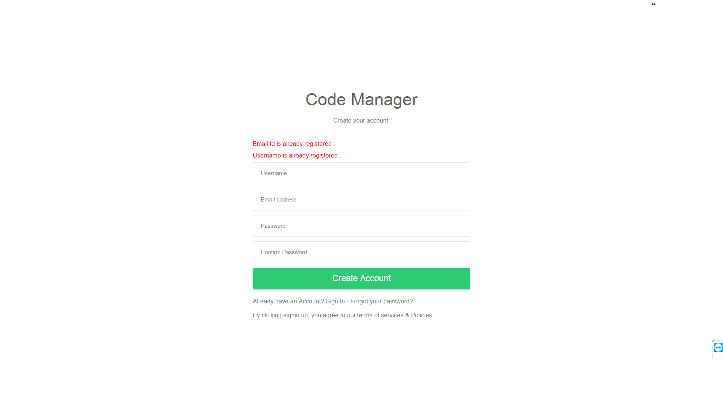
* Forgot password Screen  
    
  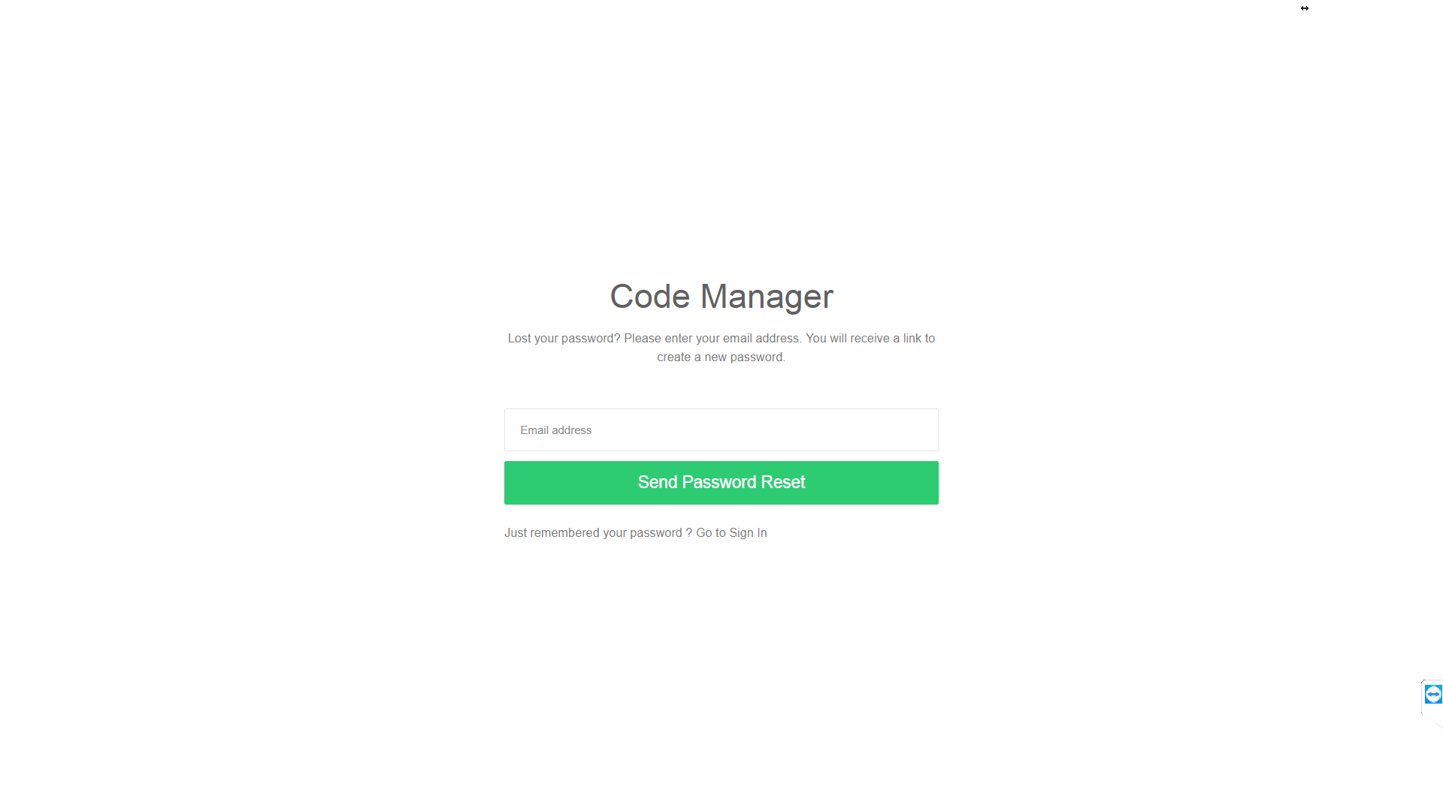
* User side validation for forgotpassword   
    
  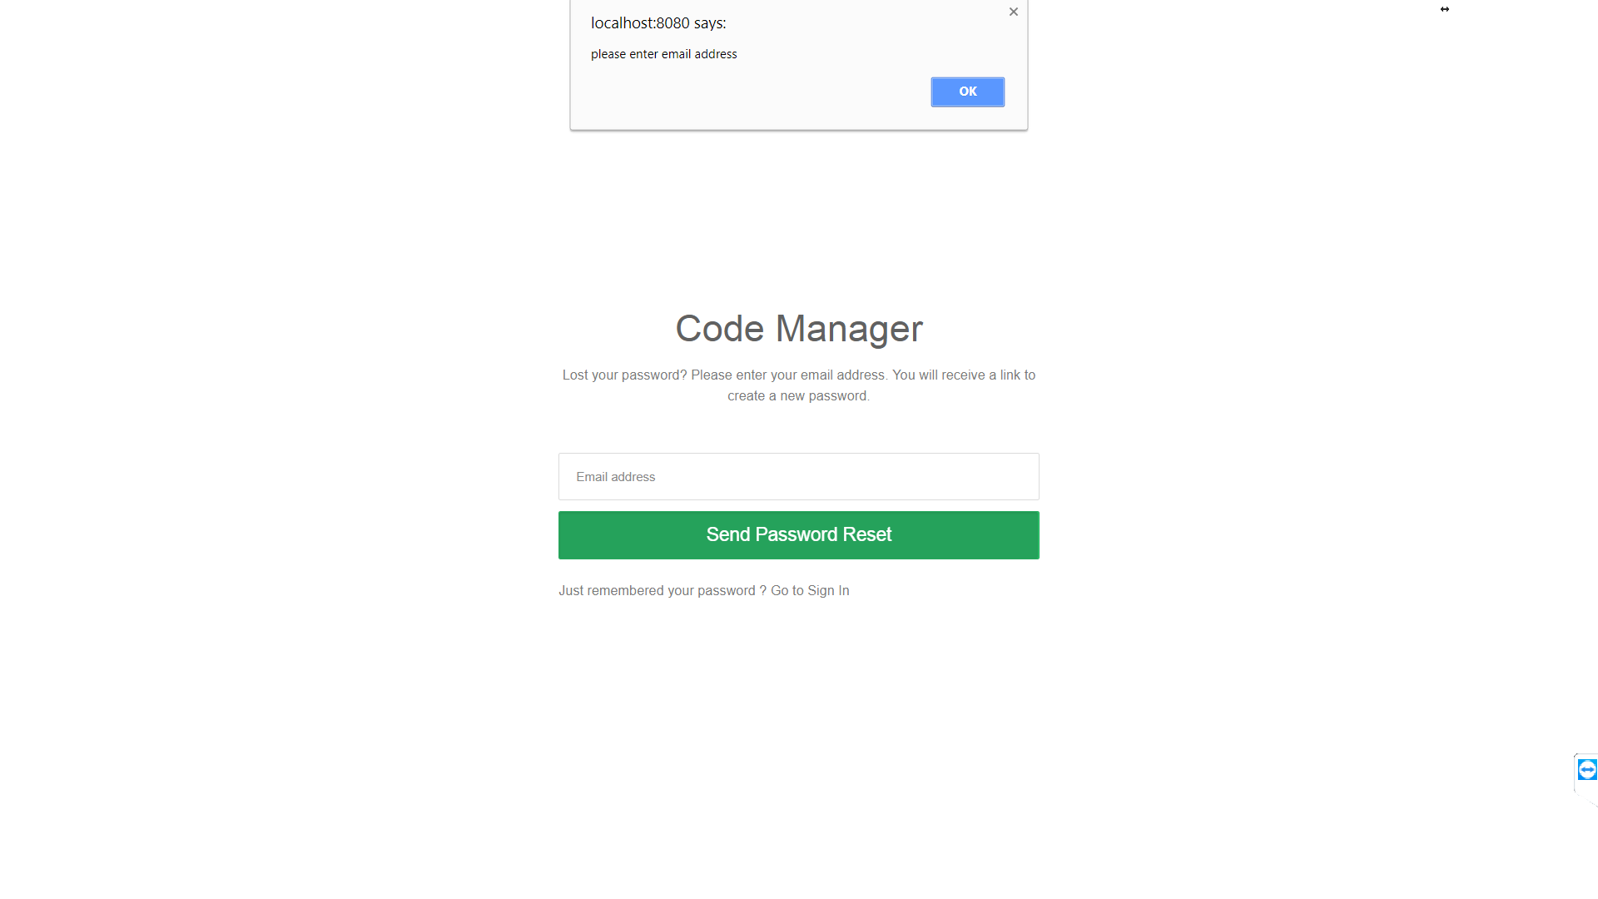
* Link sent to user to activate account  
    
  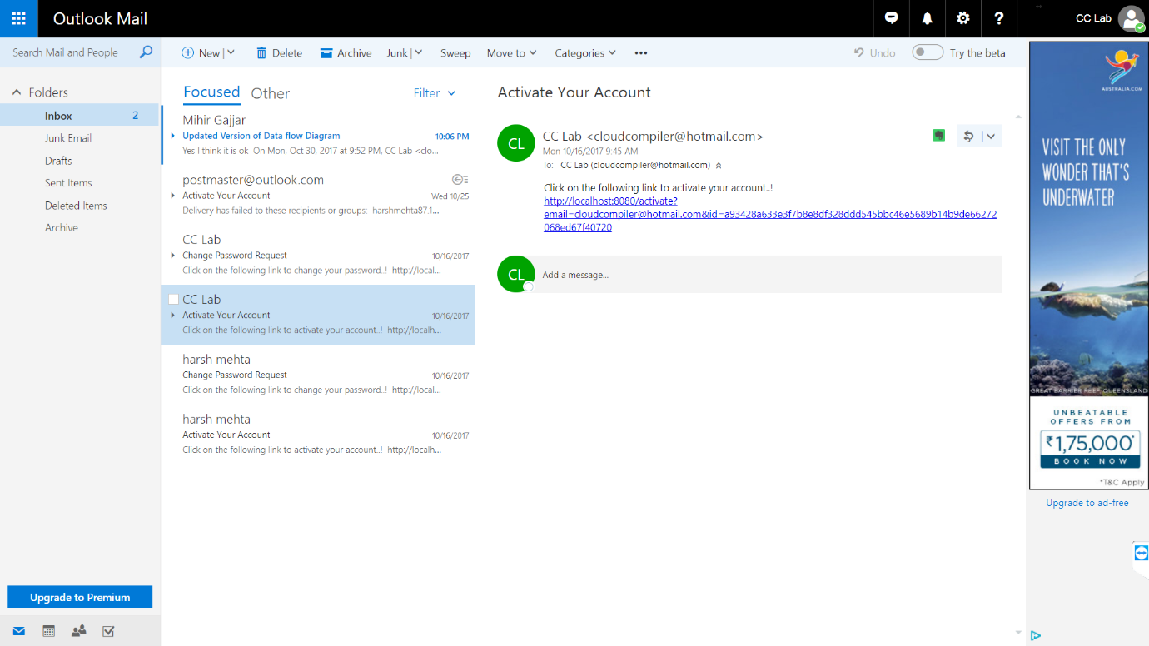
* When user go to the link for activation of an account  
    
  
* Code Editor screen  
    
  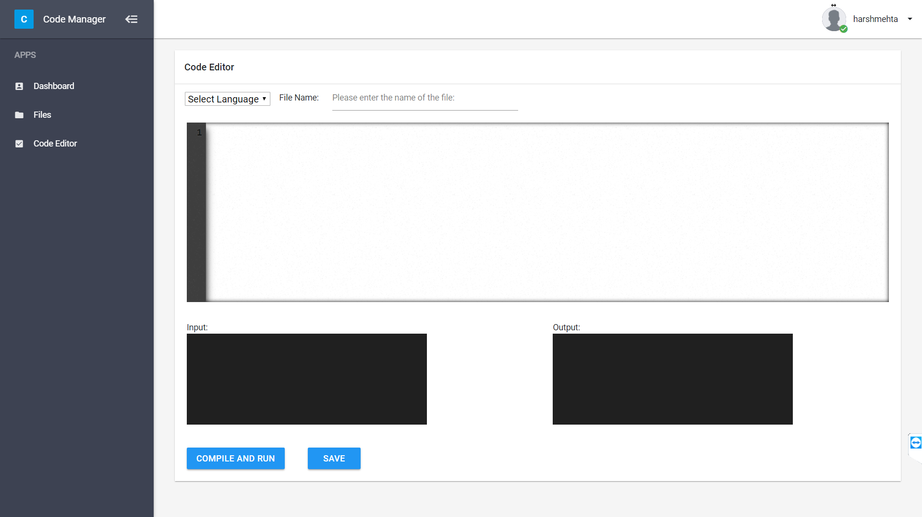
* Compilation error is showing in output  
    
  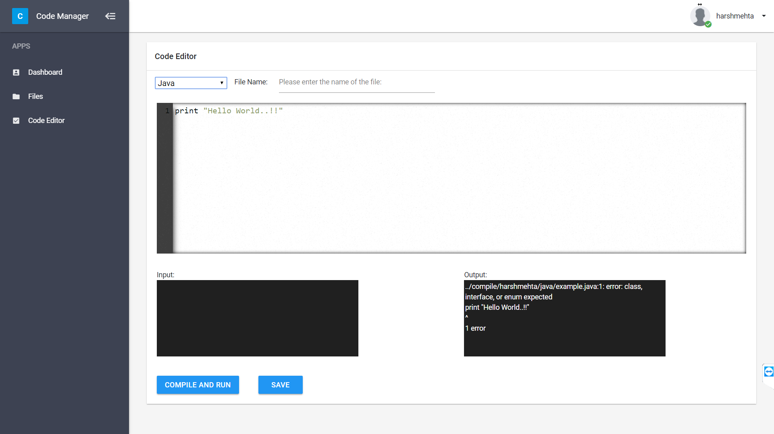
* Successful compilation  
    
  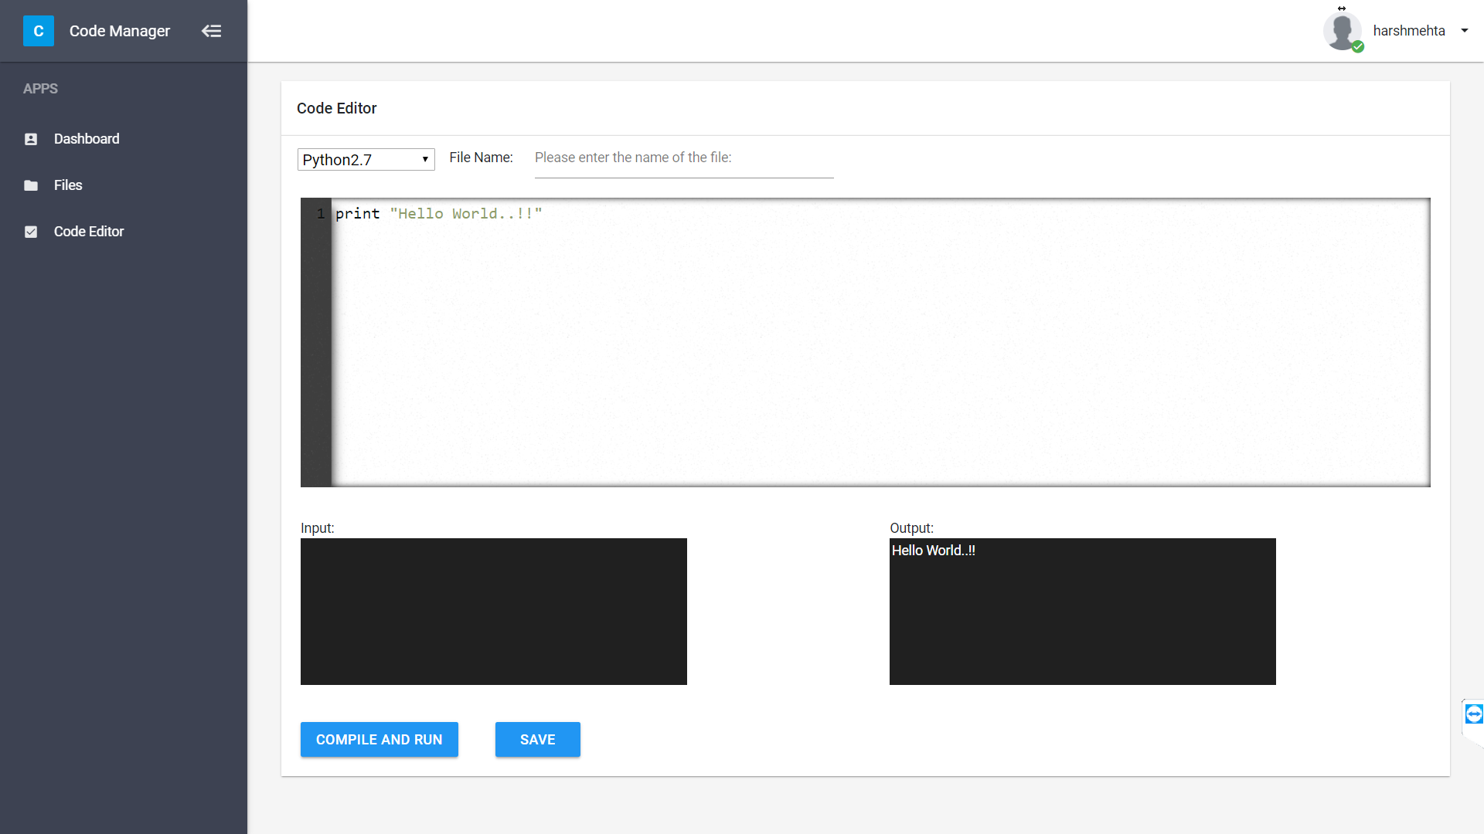
* Save file  
    
  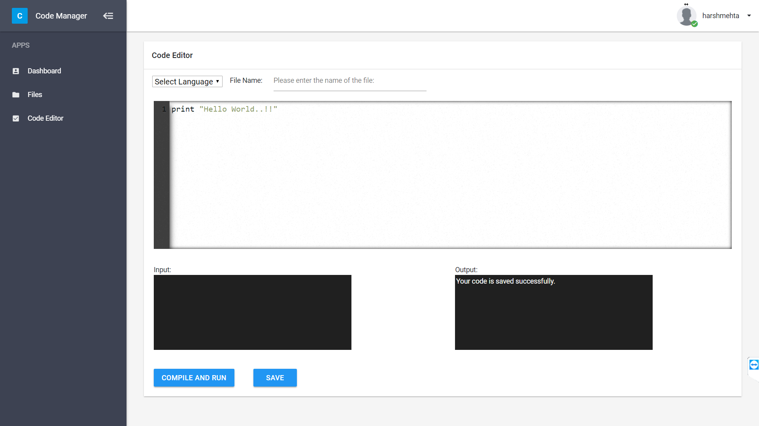
* File manager screen   
    
  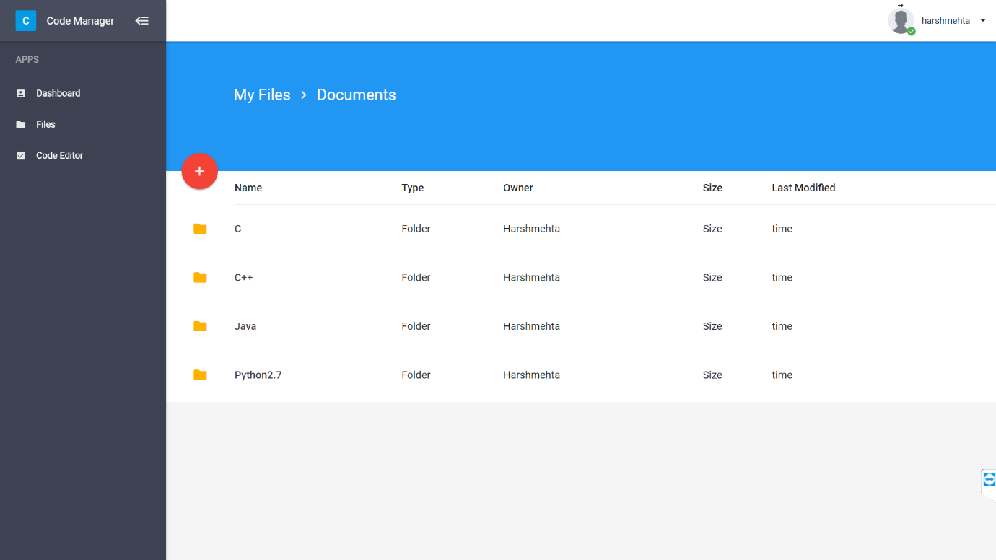  
    
    
    
    
  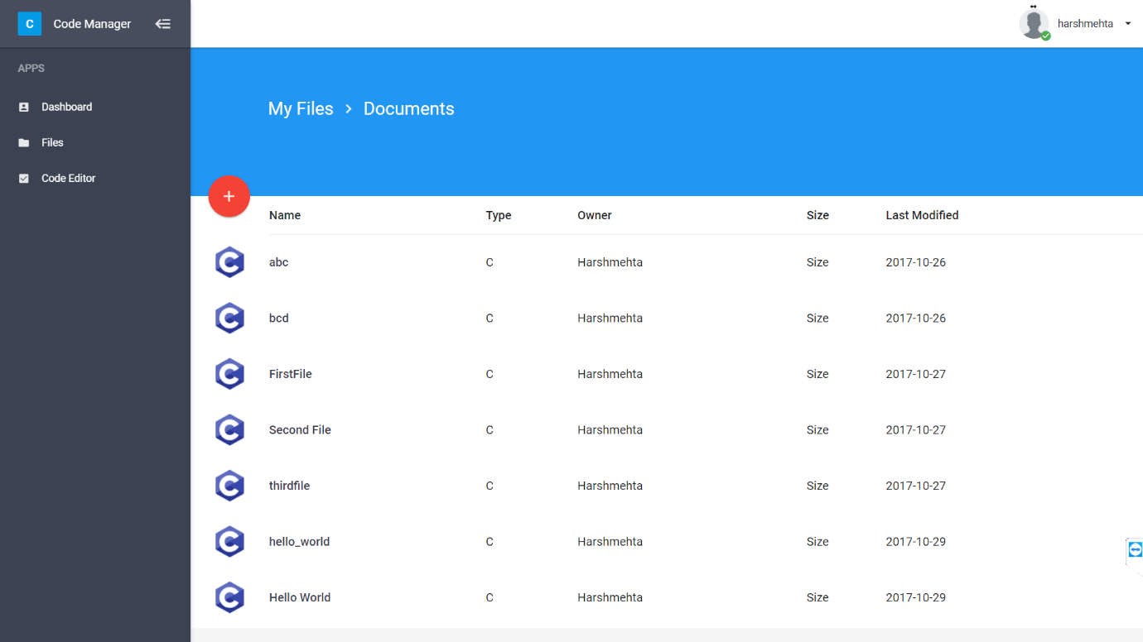  
    
    
    
    
    
    
  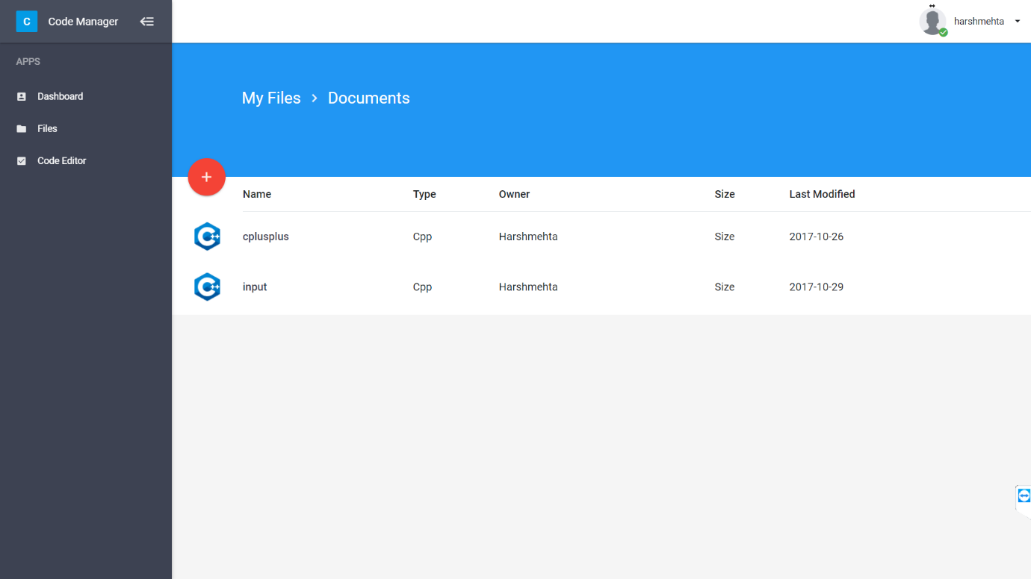  
    
    
  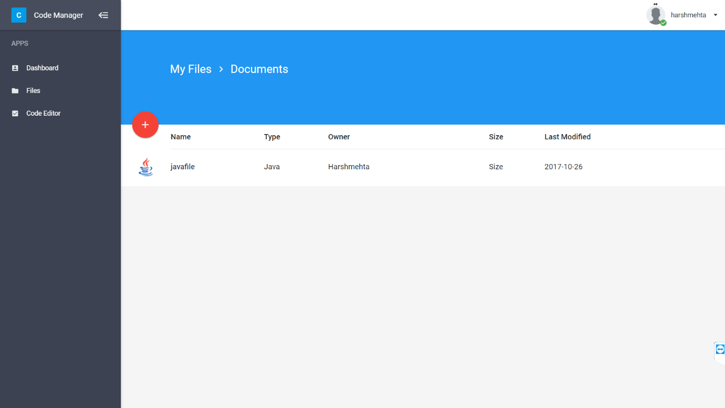  
    
    
  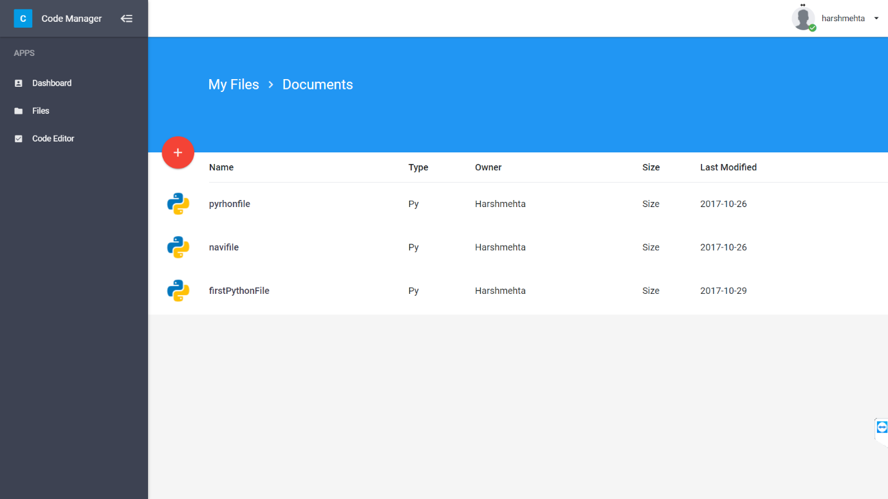

# Conclusion

Successfully implemented cloud based service oriented architecture which provides user a web based interface for compilation, execution, code suggestion and storage of code.

# Future Work

* Provide code optimization for c, c++, python
* Provide same set of service for other frequent set of programming languages
* Provide solution to error generated during compilation

# References

* Ansari, Aamir Nizam, Siddharth Patil, Arundhati Navada, Aditya Peshave, and Venkatesh Borole. "Online C/C++ compiler using cloud computing." 2011 International Conference on Multimedia Technology, 2011. doi:10.1109/icmt.2011.6002124.
* Ghaleb, Taher Ahmed. "Toward open-source compilers in a cloud-based environment: the need and current challenges." 2015 International Conference on Open Source Software Computing (OSSCOM), 2015. doi:10.1109/osscom.2015.7372684.
* Datta, Arjun, and Arnab Kumar Paul. "Online compiler as a cloud service." 2014 IEEE International Conference on Advanced Communications, Control and Computing Technologies, 2014. doi:10.1109/icaccct.2014.7019416.
* Xu X., Hu H., Hu N., Ying W. (2012) Cloud Task and Virtual Machine Allocation Strategy in Cloud Computing Environment. In: Lei J., Wang F.L., Li M., Luo Y. Network Computing and Information Security. Communications in Computer and Information Science, vol 345. Springer, Berlin, Heidelberg

# Annexure

Find following code which get input code and return status, compilation outputs, execution output and code optimization suggestions.

|  |
| --- |
| from multiprocessing import Process, Queue from suggestion import suggestJava import os, signal, sys import subprocess import time import threading import psutil  def memory_usage(z, thread_q):  """Memory usage of the current process in kilobytes."""  status = None  memory = 0  result = {'peak': 0, 'rss': 0,'data': 0, 'stk': 0}  try:  # This will only work on systems with a /proc file system  # (like Linux).  status = open("/proc/"+str(z)+"/status")  for line in status:  parts = line.split()  key = parts[0][2:-1].lower()  if key in result:  result[key] = int(parts[1])  finally:  if status is not None:  status.close()  memory = result['data']+result['stk']  thread_q.put(memory)  def getFileDetails(filename):  filename = filename.rsplit('.',1)  exe = filename[1]  filename = filename[0].rsplit('/',1)  file = filename[1]  path = filename[0]  return path, file, exe  def getCompilationStatus(compilation_args):     compilation_result = {}     popen = subprocess.Popen(compilation_args, shell=True, stdout=subprocess.PIPE, stderr=subprocess.PIPE)     compilation_result['stdout'] = popen.stdout.read()     compilation_result['stderr'] = popen.stderr.read()     return compilation_result  def getOutputStatus(execution_args, q):     thread_queue = Queue()     execution_result = {}     popen = subprocess.Popen(execution_args, shell=True, stdout=subprocess.PIPE, stderr=subprocess.PIPE)      thr = threading.Thread(target=memory_usage, args=[popen.pid, thread_queue])     thr.start()     ru = os.wait4(popen.pid, 0)[2]     thr.join()      execution_result['stdout'] = popen.stdout.read()     execution_result['stderr'] = popen.stderr.read()     execution_result['mem_usage'] = str(thread_queue.get()*0.001)+' MB'     q.put(execution_result)  def timer(timeout):  time.sleep(timeout)  def compile(path, fname, exe, lan, timeout):  compilation_status = {'stdout':"",'stderr':"",'exe_time':""}  final_status = {}   execution_command = ""  if exe=="c":  args = ("gcc -o "+path+"/"+fname+" "+path+"/"+fname+"."+exe)  compilation_status = getCompilationStatus(args)  execution_command = (path+"/"+fname+" < "+path+"/"+fname+"_input.txt")  elif exe=="java":  args = ("javac "+path+"/"+fname+"."+exe)  compilation_status = getCompilationStatus(args)  execution_command = ("java -cp "+path+" "+fname+" < "+path+"/"+fname+"_input.txt")  elif exe=="cpp":  args = ("g++ -o "+path+"/"+fname+" "+path+"/"+fname+"."+exe)  compilation_status = getCompilationStatus(args)  execution_command = (path+"/"+fname+" < "+path+"/"+fname+"_input.txt")  elif exe=="py" and lan=="py":  execution_command = ("python "+path+"/"+fname+"."+exe+" < "+path+"/"+fname+"_input.txt")  elif exe=="py" and lan=="py3":  execution_command = ("python3 "+path+"/"+fname+"."+exe+" < "+path+"/"+fname+"_input.txt")  else:  final_status['valid_selection']="False"  return final_status   final_status['valid_selection']="True"  if compilation_status['stderr']=="":  final_status['compilation_status']="True"  final_status['compilation_error']=""  q = Queue()  start = time.time()  p1 = Process(target=getOutputStatus, args=(execution_command,q,))  p2 = Process(target=timer, args=(timeout,))  p1.start()  p2.start()   while p1.is_alive() and p2.is_alive():  continue   stop = time.time()  if p1.is_alive():  final_status['execution_status'] = "False"  final_status['execution_error'] = "Terminated due to timeout"  final_status['execution_output'] = ""  final_status['execution_time'] = "-"  os.kill(p1.pid,signal.SIGKILL)  else:  checkoutput = q.get()  os.kill(p2.pid,signal.SIGKILL)   if checkoutput['stderr']=="":  final_status['execution_status'] = "True"  final_status['execution_error'] = ""  final_status['execution_output'] = checkoutput['stdout']  final_status['execution_time'] = stop - start  final_status['memory_usage'] = checkoutput['mem_usage']  final_status['suggestion'] = ""  if exe=="java":  final_status['suggestion'] = suggestJava(path, fname, 'cc2')  else:  final_status['execution_status'] = "False"  final_status['execution_error'] = checkoutput['stderr']  else:  final_status['compilation_status']="False"  final_status['compilation_error']=compilation_status['stderr']  return final_status  def getCompile(filename, lan, timeout):  path,file,exe = getFileDetails(filename)  return compile(path, file, exe, lan, timeout)  if __name__=="__main__":  filename="../compile/123/java/example.java"  print getCompile(filename, 'java', 10) |

Following code is service code return using flask App which act as a socket between application logic and input user

|  |
| --- |
| import shutil from flask import Flask, request from saveFile import saveFILE from compileCode import getCompile  app = Flask(__name__)  @app.route('/compile', methods=["POST"]) def compile():     timeout = 10     jsonRes = request.get_json()     code = jsonRes['getCode']     lan = jsonRes['type']     userID = jsonRes['userid']     filename = jsonRes['filename']     inp = jsonRes['input']       code = str(code.decode('utf-8'))     lan = str(lan.decode('utf-8'))     userID = str(userID.decode('utf-8'))     filename = str(filename.decode('utf-8'))     inp = str(inp.decode('utf-8'))      getpath = saveFILE(code, lan, userID, filename, inp)     compilation_status = getCompile(getpath,lan, timeout)     #shutil.rmtree('../compile/'+str(userID))     return str(compilation_status)  if __name__ == '__main__':     app.run(host='0.0.0.0', port=5004, debug=True, threaded=True) |

* We cannot copy paste all the codes related system considering length of document.